**EX 11: Dynamic Styling**

Your task is to **dynamically** apply a CSS class (active) to the <p>Style me</p> element in the provided React app.

The class should be applied when the <button> is clicked for the first time.

Here's how the finished app should look like BEFORE the button was clicked:

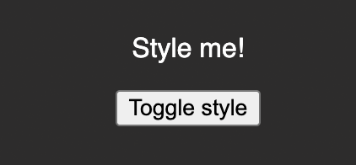

Here's how it should look like AFTER the button was clicked:

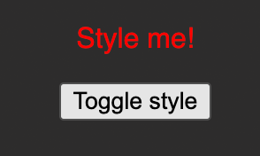

Important: Use React.useState() instead of just useState() as the latter can cause problems in this Udemy code environment.